AUTOMATED
PCB
DEFECT
DETECTION

Field | Detail
Author | Satya Suraj Pedada
Repository | github.com/satya-suraj-pedada-ds/SURAJ-Infosys-Springboard-Projects
Working dataset / weights | Google Drive folder PCB_DATASET (view link in Section 1)
Final method | YOLOv8n object detection
Primary test metric | mAP@0.5 = 0.839 (reported as ~0.84)
Scope of this document | Notebooks, GitHub artifacts, and Drive files only

ABSTRACT

Printed circuit boards are inspected for six common manufacturing defects: missing hole, mouse bite, open circuit, short, spur, and spurious copper. This work implements and evaluates an automated detector that localizes each defect on a full board image and assigns its class. An initial pipeline extracted 64×64 grayscale patches by aligning each defective photograph with a clean template, applying blur and adaptive thresholding, subtracting the two binary images, and cropping contour regions. The patches were intended for image classification. Classification of pre-cropped regions does not produce bounding boxes on an uncropped board, and the web interface therefore could not show usable detections. That approach was replaced by single-stage object detection. YOLOv8n was trained on the public six-class PCB dataset stored as PCB_DATASET (Pascal VOC XML annotations and template boards in PCB_USED; not the Deep PCB dataset). Official boxes were converted to the YOLO format and 693 images were split into training, validation, and test subsets (70% / 15% / 15%). Training used input size 640, batch size 16, and up to 80 epochs on CPU. The 64×64 patches from the first phase were not used as training data. On the held-out test split (104 images, 446 instances) the model obtained mAP@0.5 = 0.84, mAP@0.5:0.95 = 0.44, mean precision = 0.88, and mean recall = 0.75. Performance is strongest on missing holes and weaker on small track defects (spur and mouse bite). A Streamlit application loads the saved weights, runs inference at confidence 0.25 and IoU 0.45, and returns labelled boxes with a downloadable annotated image. The result reported for this project is test mAP@0.5 = 0.84 from the detection evaluation, not a classification score from the first phase.

1. Purpose and Sources
This report documents the PCB defect project as it exists in the GitHub repository and the link Google Drive folder. It does not reuse claims from the earlier Word/PPT write-up. Numbers below are taken from executed notebook outputs.
GitHub: https://github.com/satya-suraj-pedada-ds/SURAJ-Infosys-Springboard-Projects
Google Drive (dataset, labels, runs, weights): https://drive.google.com/drive/folders/1jckJoBLvpNfM4YSmr34En9ao4PbfXl9F?usp=drive_link
Drive sharing used for review: Anyone with the link, Viewer.

2. Problem
Printed circuit boards pick up manufacturing defects during etching, drilling, and related steps. Inspection has to answer two questions on one photo: where is the defect, and which of the six types is it.
A classifier that only labels a pre-cropped patch cannot drive a web interface that accepts a full board image. A detector that returns boxes and class names can.
Defect Classes Used In Code
Class name in code | What it is
missing_hole | Drilled hole is absent
mouse_bite | Small bite or erosion on a copper track
open_circuit | Break in a copper track
short | Unintended copper bridge between tracks
spur | Thin extra copper protrusion
spurious_copper | Leftover copper island not part of the design

Objective of the project
To build a PCB defect detection system that can:
- Localize and classify the six defect types on the project dataset
- Return a bounding box and confidence score for each detection
- Show the result in a simple web interface (upload, table, download)

3. Dataset (from Drive and Notebook Paths) Notebooks mount Google Drive and use BASE_PATH / BASE_DIR = /content/drive/MyDrive/PCB_DATASET/. Folder names match the public six-class PCB defect set with official XML boxes and clean template boards. This is not the Deep PCB set.
3.1 Raw Files Given With The Dataset
Drive path | Used by | Role
images/<class>/ | M1 and M2 | Raw defective photos, names like 01_missing_hole_07.jpg
Annotations/<class>/ | M2 | Pascal VOC XML boxes for each photo
PCB_USED/01.JPG … 12.JPG | M1 | Clean template boards (no 02.JPG or 03.JPG in the set)
rotation/ and rotate.py | Not used | Official rotated copies. No notebook in this repo reads them
Milestone 2 copied 693 JPG files from the six images/ folders into images_combined/. Train/val/test were split from that list (70% / 15% / 15%, random_state=42). After XML matching, validation and test each had 104 labeled images (452 val instances, 446 test instances).

4. Project History In The Notebooks
4.1 Phase 1 — Milestone 1 (Modules 1–2): Patch Extraction
Six notebooks, one per class: Missing_Holes, Mouse_Bite, Open_Circuit, Short, Spur, Spurious_Copper.
The internship path started with classification on small crops (EfficientNet-style). Milestone 1 in this repository is the crop generator, not a trained EfficientNet notebook. Crops were meant for that classifier. Classification on ready 64×64 patches can look strong and still fail in a UI that receives a full board, because the classifier never localizes defects.
Algorithm in the six notebooks
- Mount Drive; read images/<Class>/ and PCB_USED templates.
- Parse template id from the file name: 01_missing_hole_07.jpg → 01.JPG.
- Convert both images to grayscale.
- Resize both to one-quarter of the template height and width.
- Gaussian blur 3×3.
- Adaptive mean threshold, block size 15, C = 5.
- cv2.subtract(thresh_template, thresh_test).
- Median blur 3, then Otsu threshold.
- External contours with area between 1 and 300.
- Take a 64×64 window around the contour center; save only full 64×64 patches as PNG.
Outputs landed in PCB_USED/<class>/ as missing_hole_defect_0000.png and similar files, plus dummy Drive-sync text files. Notebook logs included 479 missing-hole patches and 77 short patches from the same area gate. One-way subtract keeps pixels present on the template and missing on the test board, so additive defects (short, spur, spurious copper) are under-represented. That is a limitation of Phase 1, not of YOLO.
These patches were not used to train the YOLOv8 model in Milestone 2.
4.2 Phase 2 — Milestone 2 (Modules 3–4): Detection After patch classification did not place boxes correctly in the web interface, the detector path replaced it.
Module 3 notebook (title in file still says training + analysis) does the following:
- Copy all class folders into images_combined/ (693 images in the run log).
- Split unique images into train / val / test.
- Find the XML next to the image name under Annotations/<class>/.
- Convert each object name to a class id and each bndbox to YOLO normalized cx, cy, w, h.
- Write pcb_yolo_dataset.yaml.
- Train YOLO('yolov8n.pt') and copy runs/pcb_yolo/weights/best.pt to best_yolov8_pcb.pt.
- Validate on the val split.
Module 4 notebook loads that model, plots results.csv, shows the confusion matrix, runs model.val(split='test'), then draws red boxes on up to 20 images per class from images/.
4.3 Phase 3 — Milestone 3 (Modules 5–6): Streamlit app The notebook writes app.py. The app loads best_yolov8_pcb.pt, accepts jpg/jpeg/png, runs YOLO at conf=0.25 and iou=0.45, draws thick red boxes with class and confidence, shows a table, and offers a JPEG download. It was started on Colab port 8501 with a Cloudflare tunnel. The model path is the Drive file, not a file stored in GitHub.
5. Training Configuration (from Module 3)
Setting | Value In Notebook
Base weights | yolov8n.pt
data | pcb_yolo_dataset.yaml
epochs | 80
patience | 15
imgsz | 640
batch | 16
device | 0 if CUDA else CPU (this run logged CPU)
project / name | PCB_DATASET/runs / pcb_yolo
exist_ok | True
6. Results (From Executed Notebooks and Drive) Detection performance is reported with box mAP, not classification accuracy. The headline test figure for this project is mAP@0.5 = 0.839.
6.1 Validation (Module 3) Split: val. Images: 104. Instances: 452.
Class | Precision | Recall | F1 | mAP@0.5 | mAP@0.5:0.95
all | 0.872 | 0.726 | — | 0.809 | 0.393
missing_hole | 0.991 | 0.971 | 0.981 | 0.992 | 0.594
mouse_bite | 0.751 | 0.605 | 0.670 | 0.715 | 0.342
open_circuit | 0.796 | 0.746 | 0.770 | 0.807 | 0.356
short | 0.900 | 0.763 | 0.826 | 0.820 | 0.388
spur | 0.851 | 0.598 | 0.702 | 0.717 | 0.331
spurious_copper | 0.942 | 0.672 | 0.785 | 0.802 | 0.348

6.2 Test (Module 4) — Primary Reported Result Call: model.val(data=yaml, split='test', conf=0.25, iou=0.45). Images: 104. Instances: 446.
Metric | Value
Test mAP@0.5 | 0.84
Test mAP@0.5:0.95 | 0.44
Mean precision | 0.88
Mean recall | 0.75
Mean F1 | 0.80

Class | Images | Instances | Precision | Recall | mAP@0.5 | mAP50-95
all | 104 | 446 | 0.881 | 0.748 | 0.839 | 0.442
missing_hole | 15 | 59 | 1.000 | 0.983 | 0.991 | 0.622
mouse_bite | 25 | 112 | 0.861 | 0.607 | 0.740 | 0.340
open_circuit | 16 | 65 | 0.754 | 0.754 | 0.837 | 0.395
short | 15 | 63 | 0.911 | 0.810 | 0.886 | 0.443
spur | 19 | 83 | 0.870 | 0.566 | 0.739 | 0.362
spurious_copper | 14 | 64 | 0.891 | 0.766 | 0.842 | 0.488

Drive file final_test_evaluation_report.txt repeats the same per-class precision / recall / F1 values (overall line printed as 83.8975%). The support column in that text file is formatted as 0 and should be ignored; instance counts above come from the Ultralytics val table.

7. Application Behaviour (from app.py in Milestone 3)
Item | Implementation
Model file | best_yolov8_pcb.pt on Drive
Load | YOLO(MODEL_PATH) cached with @st.cache_resource
Inference | model(pil_image, conf=0.25, iou=0.45)
Drawing | Red rectangle width 6; label = class + confidence
UI | Two columns: upload | result table + annotated image + download

8. File Map 8.1 GitHub Repository
Path | What It Is
PCB-Milestone - 1(Module 1 and Module 2) | Phase 1 patch extraction, one notebook per class
PCB-Milestone - 2(Module 3) | YOLO dataset build + training + val
PCB-Milestone - 2( Module 4) | Curves, test val, boxed inference
PCB-Milestone - 3(Module 5 and Module 6) | Writes and launches Streamlit app
PCB-Milestone - 4(Module 7 and Module 8) | Documentation and PPT
Results/Sample_*_Detections/ | Example detection screenshots
README.md | Project summary

8.2 Google Drive PCB_DATASET — Created By Code
Path | Created by | What it is
PCB_USED/<class>/*_defect_XXXX.png | Milestone 1 | 64×64 grayscale crops
images_combined/ | Module 3 | All raw JPGs in one folder
yolo_dataset/train|val|test | Module 3 | Split images, YOLO .txt labels, labels.cache
pcb_yolo_dataset.yaml | Module 3 | nc=6, names, split paths
runs/pcb_yolo/ | model.train / plots | Logs, curves, confusion matrix, weights
best_yolov8_pcb.pt | Module 3 copy | Weights the app loads
results/yolo_red_boxes/ | Module 4 | Annotated full-board images
final_test_evaluation_report.txt | Evaluation | Test precision/recall/F1 dump

9.Final OutPut :
The model detects all six classes. Missing hole is strongest (test mAP@0.5 = 0.99). Spur and mouse bite are weaker (recall 0.57 and 0.61) because those defects are small
9.1 Missing Holes
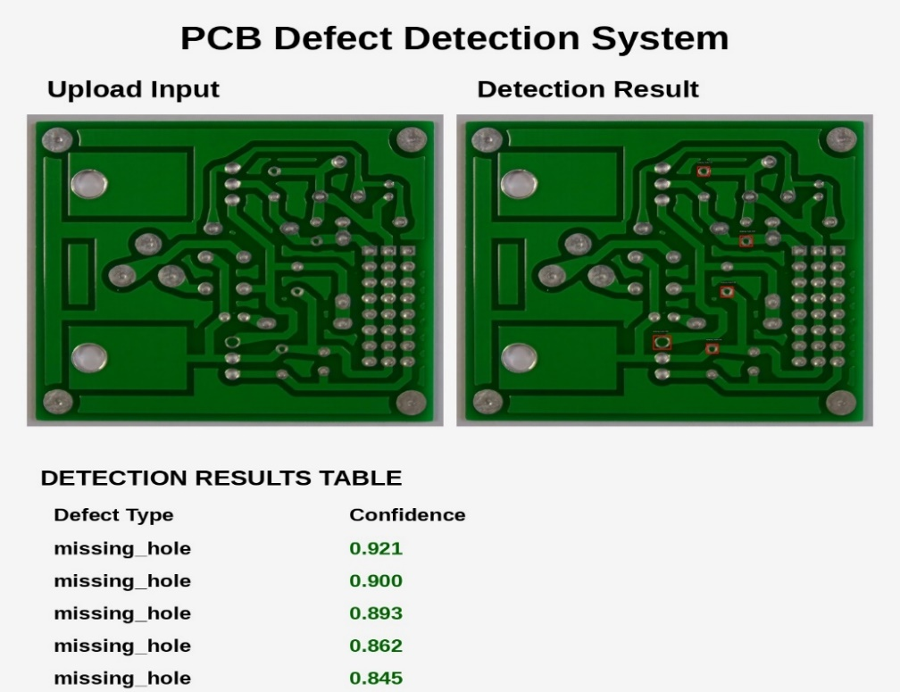

9.2 Mouse Bite
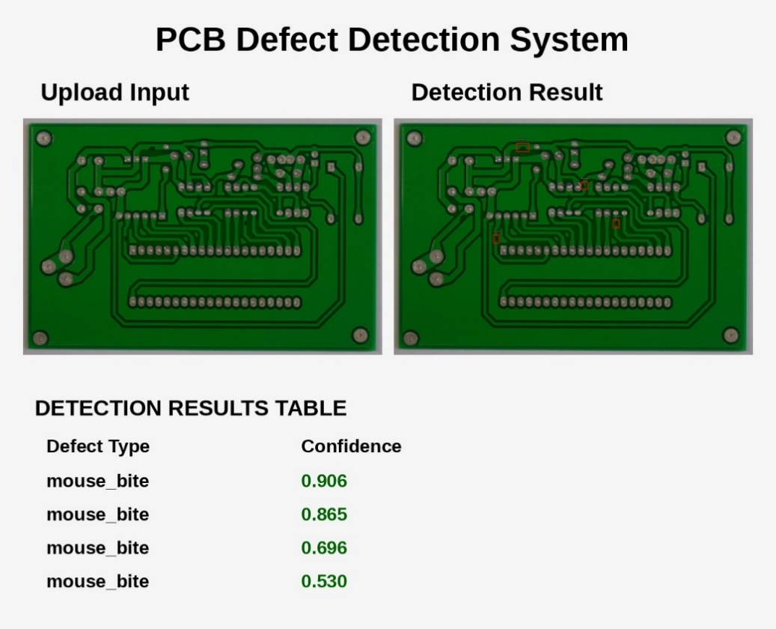
9.3 Open Circuit
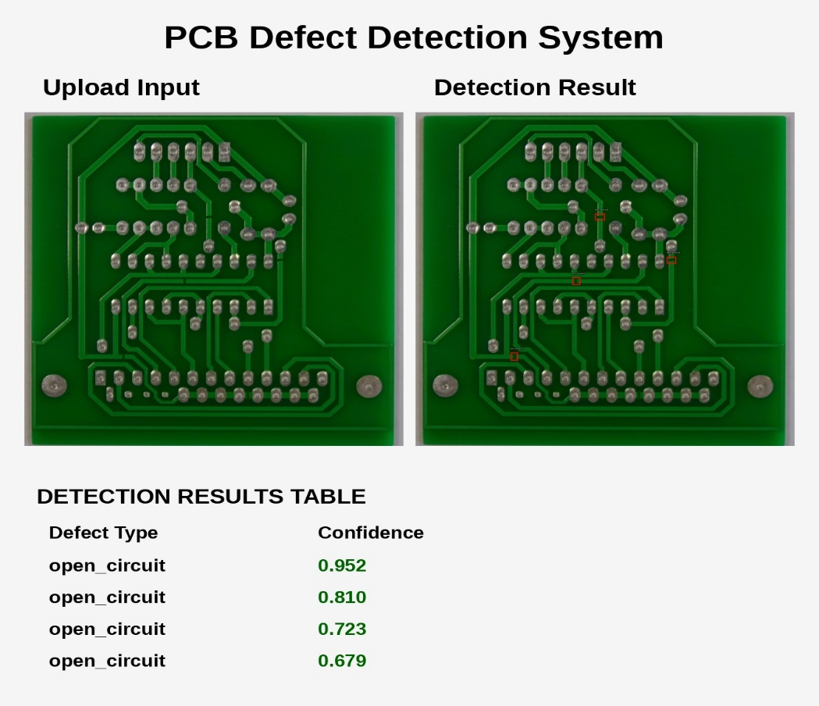

9.4 Shorts
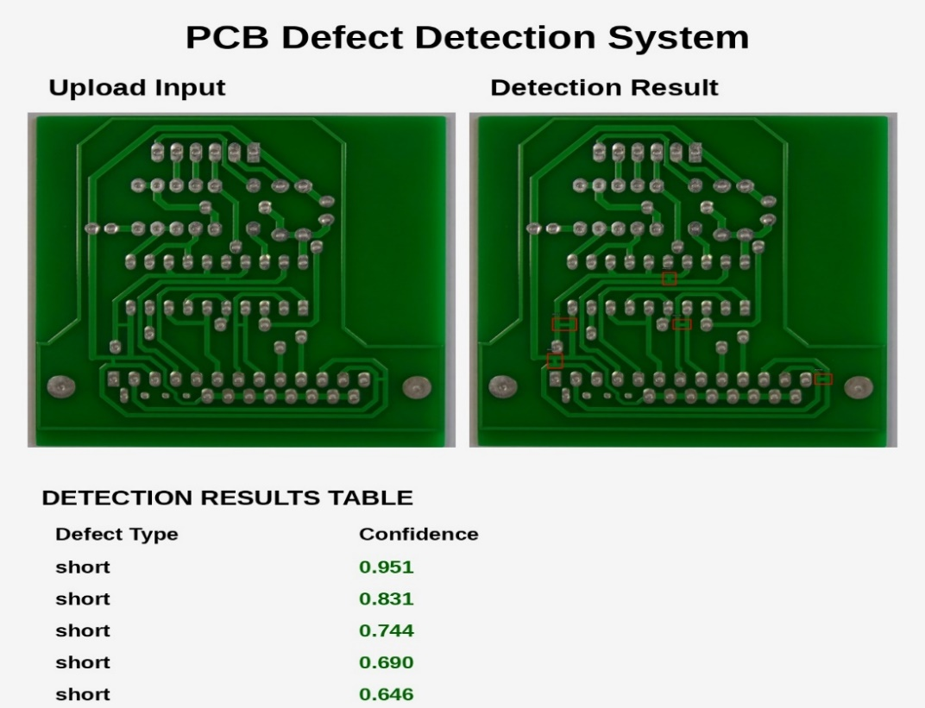
9.5 Spur
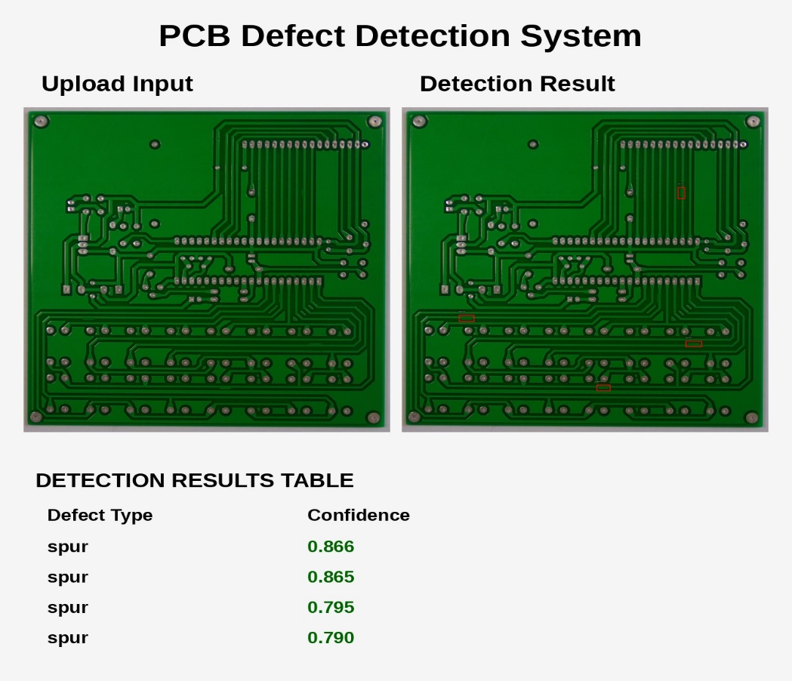

9.6 Spurious Copper
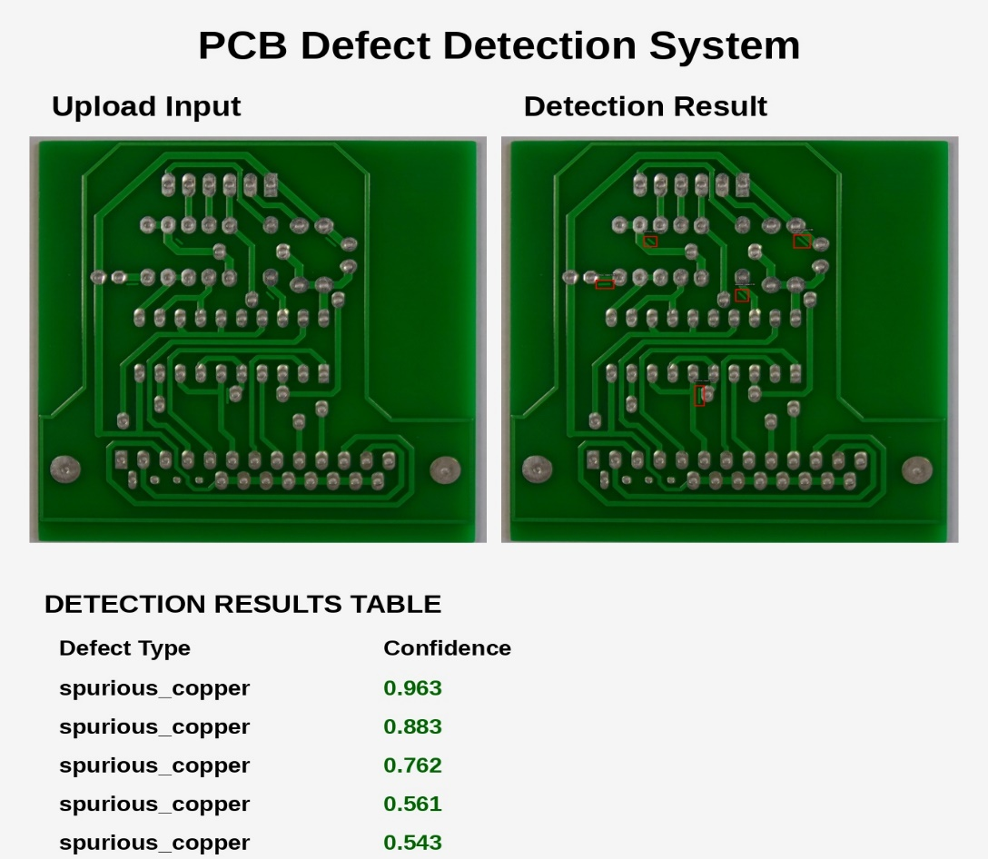
9. Limitations
- Final detector is YOLOv8n trained on this public aligned set. It is not validated on random phone photos or a production AOI line.
- This training run used CPU. A GPU run with a larger YOLO variant is the first obvious experiment, not more epochs on the same nano model after the curve flattens.
- patience=15 may stop before epoch 80 if validation stops improving. The live epoch count is in runs/pcb_yolo/results.csv.
- Train/val/test split is random, not stratified by class.
- Images with missing XML are skipped (continue / bare except).
- Module 4 does not redefine OUTPUT_DIR, ANNOTATIONS_DIR, or PIL drawing imports; it depends on Module 3 state if cells are run in order.
- Milestone 1 one-way subtract is the wrong difference for additive copper defects. That path is not part of the shipped detector.
- Weights and the dataset live on Drive. Cloning GitHub alone does not load the model.

10. Re-Running The Detector
- Keep or download PCB_DATASET so images/, Annotations/, and best_yolov8_pcb.pt are available.
- Training: Milestone 2 Module 3 notebook, after Drive mount.
- Test metrics: Milestone 2 Module 4, model.val(split='test').
- Demo: Milestone 3 notebook, or run the written app.py with MODEL_PATH pointed at best_yolov8_pcb.pt.
- Do not train YOLO on the 64×64 PNG patches unless the project is explicitly changed back to classification.

11. Summary
Phase 1 built 64×64 difference crops for a classification attempt. That attempt did not localize defects on a full board in the web UI.
Phase 2 trained YOLOv8n on full images and official XML boxes. On the held-out test split the model reached mAP@0.5 = 0.839, mean precision 0.881, mean recall 0.748. Missing hole is strong. Spur and mouse bite are the weak classes.
Phase 3 wrapped that model in a Streamlit upload demo using the same confidence and IoU thresholds as the test call.
The correct number to quote for this repository is test mAP@0.5 ≈ 0.84 from Module 4, not a classification score from the first phase.

